**Name of Student: Ramit Bose**

**Reg.No.: 21BCE1316**

**Ex. No:9**

**Date :31-03-2023**

**Title:  Design and Demonstration of Test Cases**

**AIM** : To do the following tests:

1. Unit testing using Junit
2. Integration Testing
3. Regression Testing

**SOFTWARE USED** : Selenium and NetBeans

**UNIT TESTING**

Unit testing involves the testing of each unit or an individual component of the software application. It is the first level of functional testing. The aim behind unit testing is to validate unit components with its performance.

A unit is a single testable part of a software system and tested during the development phase of the application software.

The purpose of unit testing is to test the correctness of isolated code. A unit component is an individual function or code of the application. White box testing approach used for unit testing and usually done by the developers.

Whenever the application is ready and given to the Test engineer, he/she will start checking every component of the module or module of the application independently or one by one, and this process is known as Unit testing or components testing.

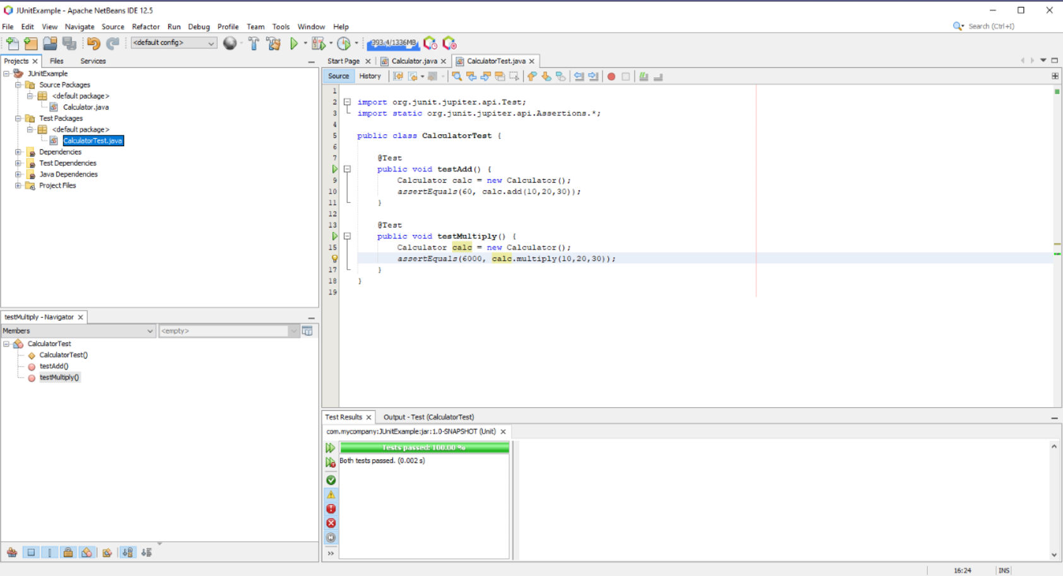

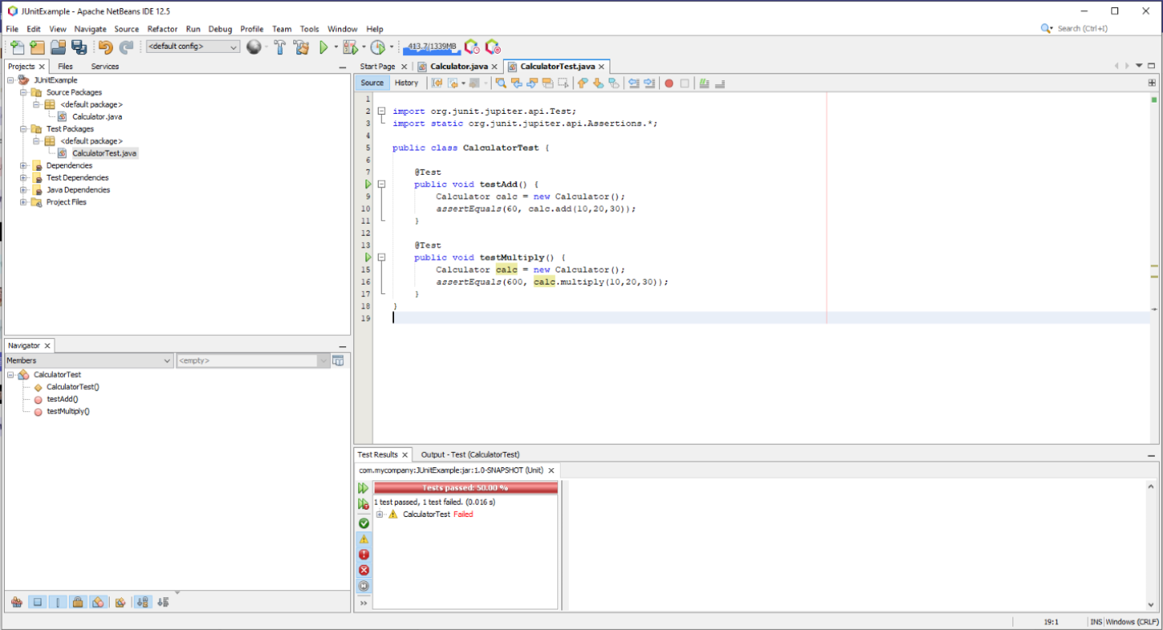

**INTEGRATION TESTING**

Integration testing is the second level of the software testing process comes after unit testing. In this testing, units or individual components of the software are tested in a group. The focus of the integration testing level is to expose defects at the time of interaction between integrated components or units.

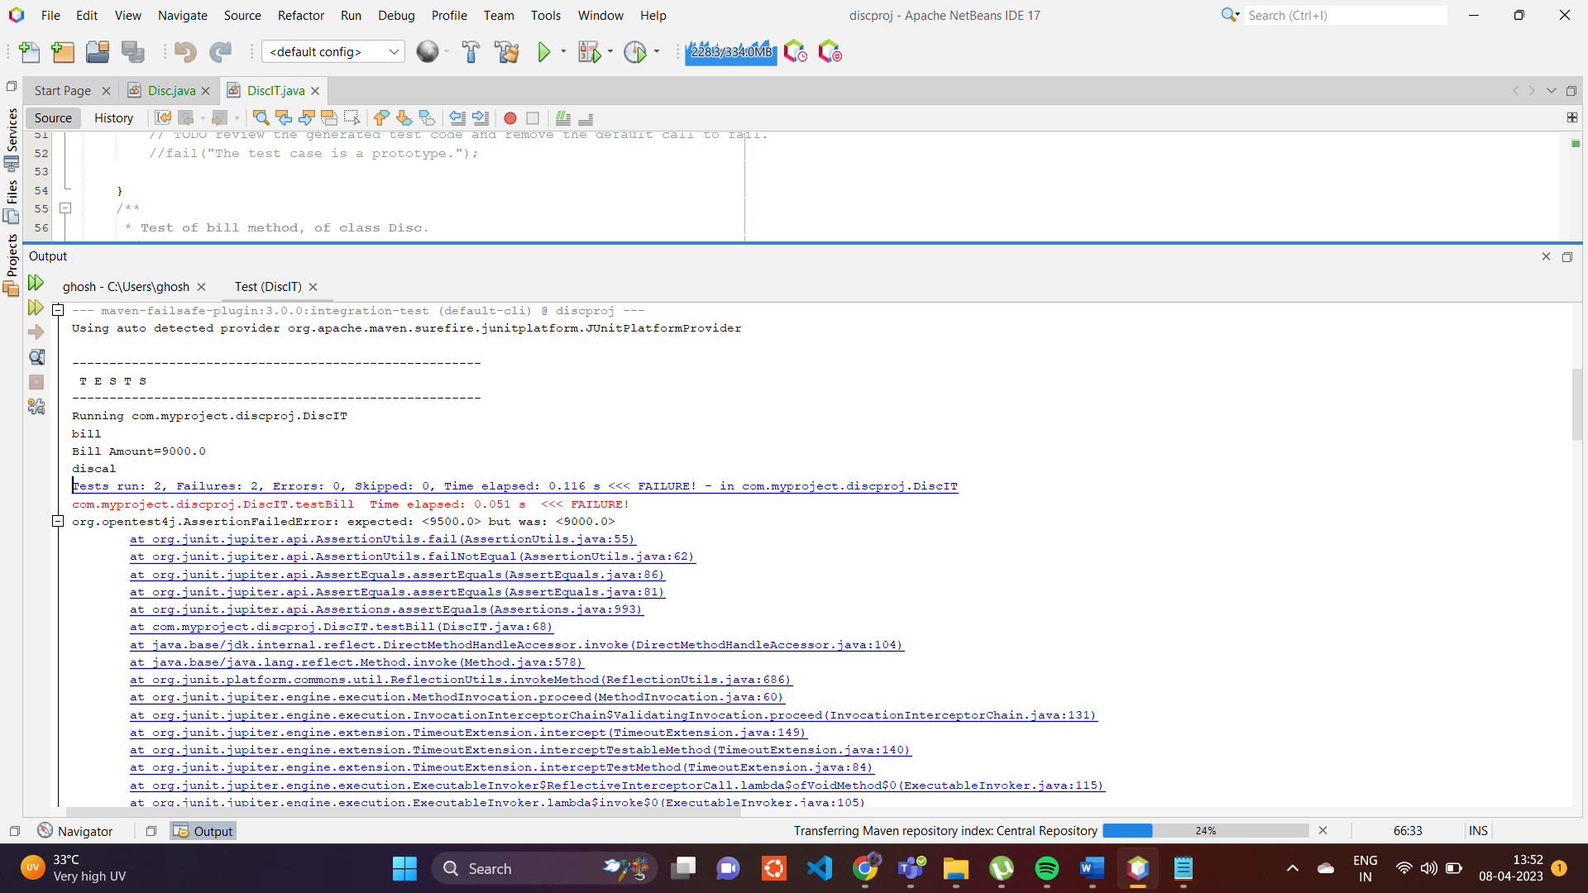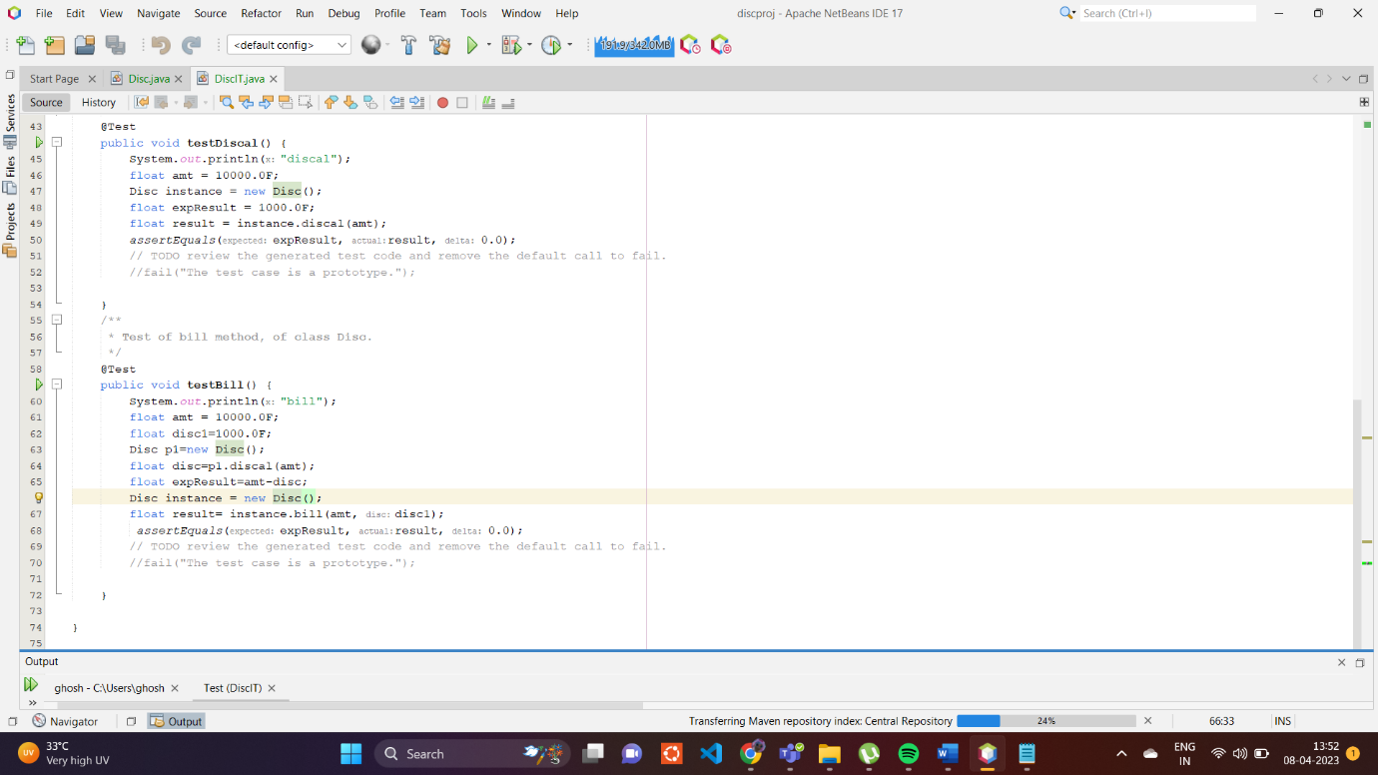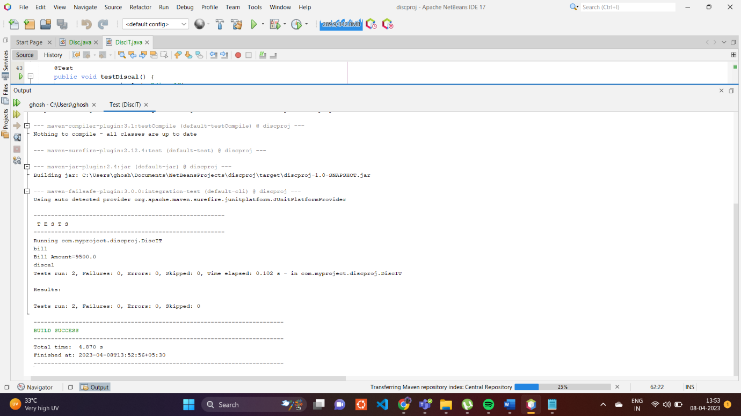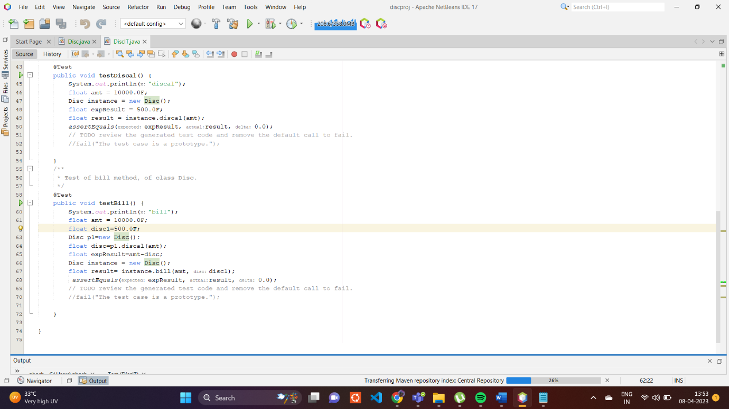

**REGRESSION TESTING**

Regression testing is a black box testing technique. It is used to authenticate a code change in the software does not impact the existing functionality of the product. Regression testing is making sure that the product works fine with new functionality, bug fixes, or any change in the existing feature.

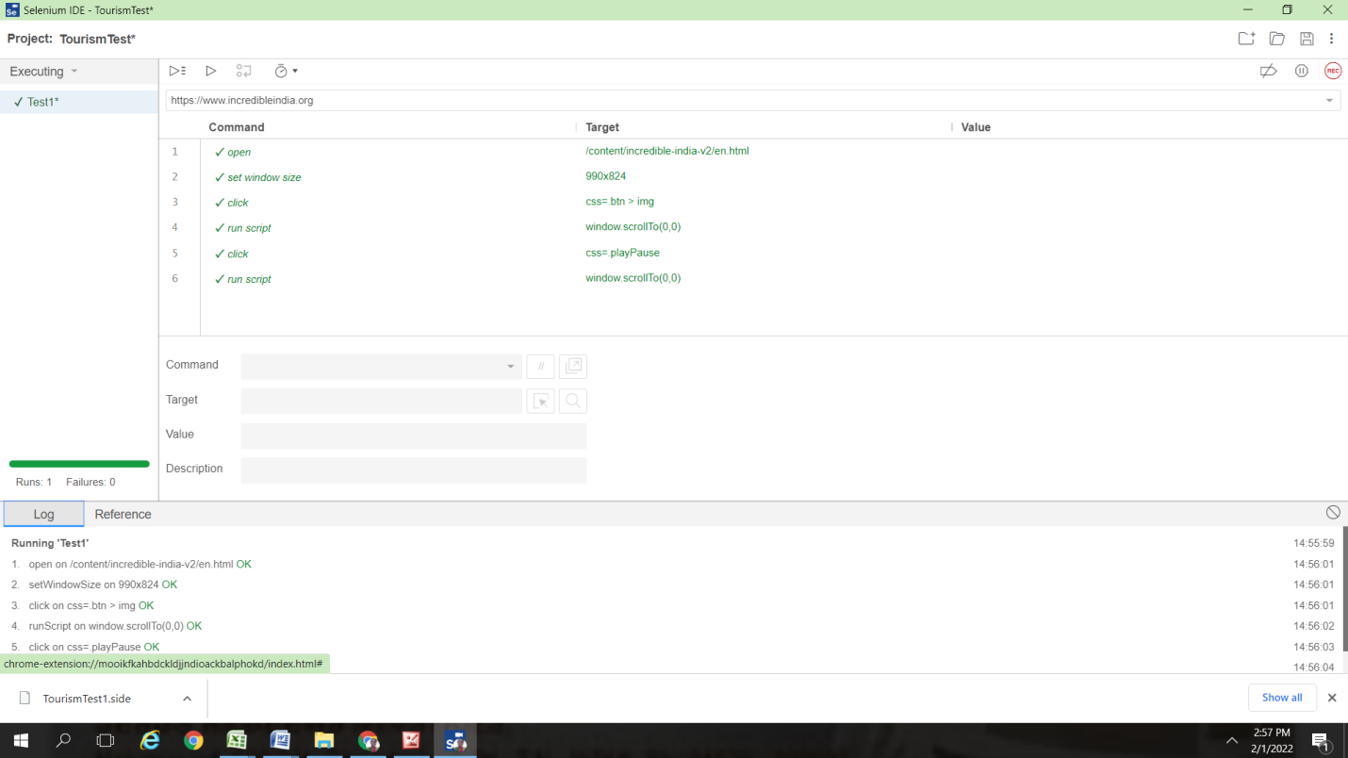

**RESULT**

Thus, learnt how different software testing procedures are done software applications to ensure working of the application.